RISK ASSESSMENT FOR The Institute of Imagination (iOi)

Location Details | Assessment by  Event Organisers | Date of events:

Event Plan

As part of the iOi Schools Programme, Imagine Me Imagine You is a creative learning programme for children and young people in primary schools across the UK. The iOi Schools Programme is a virtual learning programme, taking place over 4 weeks, with Teacher Training, Workshops and Show & Tell sessions broadcast directly into your classrooms. Resources and materials are sent as part of activity Toolkits and sessions take place in your own classrooms or spaces in your school, and pupils work either individually or collectively.
The purpose of the Balancing ‘Me’ Sculptures workshop is to build and create sculptures using balance, gravity and mass, out of everyday objects to explore the neuroscience of the brain celebrating our unique secret code.
Please find a template Risk Assessment below as a guide to develop one for your class that is tailored to the specific needs of your students, school and classroom environment.
Risk scoring
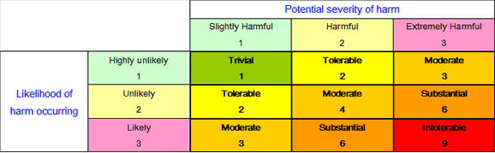

Hazard / Risk | Who is at Risk? | How can the hazards cause harm? | Control Measures | Risk Score
Hazards from interaction with workshop materials  - Wire  - Pipe cleaners | - Participating children  - Teaching staff | - Injury to eyes  - Cuts | - Supervision of materials use and application  - Staff to encourage and instruct to support children in safely using the equipment  - Ensure that children are evenly spaced out, e.g. utilising space on carpet so that they have enough room not to bump into other children | 3  Moderate
Hazards from interaction with workshop materials  - Pliers/Cutters | - Participating children  - Teaching staff | - Injury to fingers | - Teachers to handle the pliers/cutters and cut wire for each child ahead of sessions  - Ensure that pliers/cutters are kept away from children  - If children have difficulty bending wires, they could use pencils or other blunt objects to wrap wire round rather than the pliers | 3  Moderate

If you have any queries, please get in touch at: schools@ioi.london

